**Name: VYSHNAVI BABU S**

**Roll No: 55**

**Batch: B**

**Date: 4-04-2022**

**NETWORKING & SYSTEM ADMINISTRATION LAB**

**Experiment No.: 2**

**Aim**

Hardware components

**Procedure**

## CPU (Central Processing/Processor Unit)

The CPU (Central Processing Unit or processor) is responsible for processing all information from programs run by your computer. The ‘clock speed’, or the speed at which the processor processes information, is measured in gigahertz (GHz). This means that a processor advertising a high GHz rating will likely perform faster than a similarly specified processor of the same brand and age.

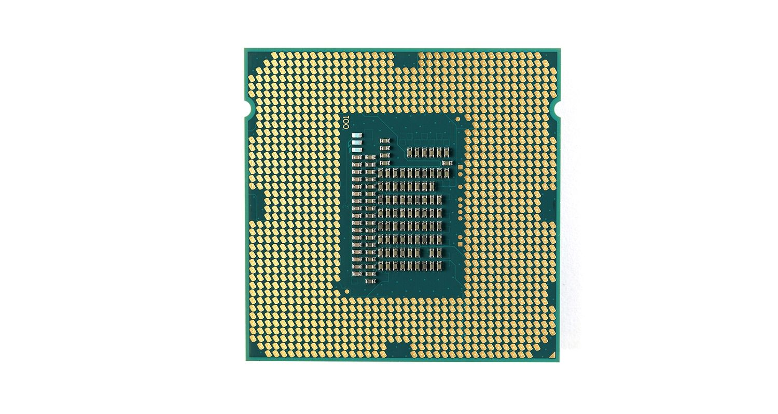

1. **Hard drive**

The hard drive is a storage device responsible for storing permanent and temporary data. This data comes in many different forms, but is essentially anything saved or installed to a computer: for example, computer programs, family photos, operating system, word-processing documents, and so on.

There are two different types of storage devices: the traditional hard disk drive (HDD) and the newer solid state drives (SSD). Hard disk drives work by writing binary data onto spinning magnetic disks called platters that rotate at high speeds, while a solid-state drive stores data by using static flash memory chips.

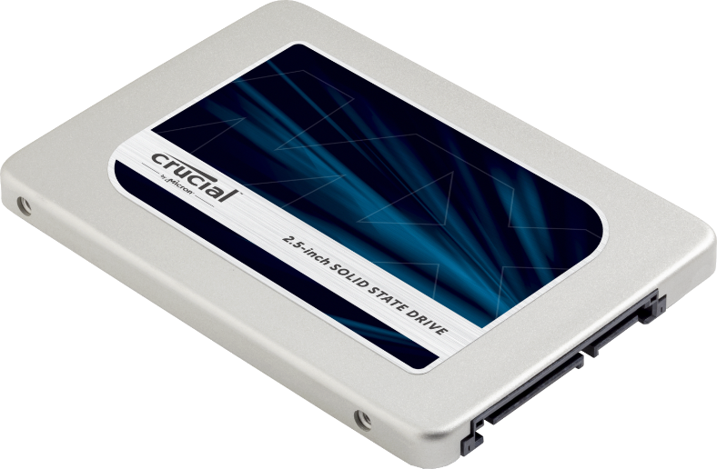

## Graphics Processing Unit (GPU)

Especially important for 3D rendering, the GPU does exactly what its name suggests and processes huge batches of graphic data. As opposed to the basic on-board graphic capabilities that PC motherboards supply, dedicated graphics cards interface with the motherboard via an expansion slot to work almost exclusively on graphic rendering. This also means we can upgrade our graphics card if we want to get a bit more performance from our PC.

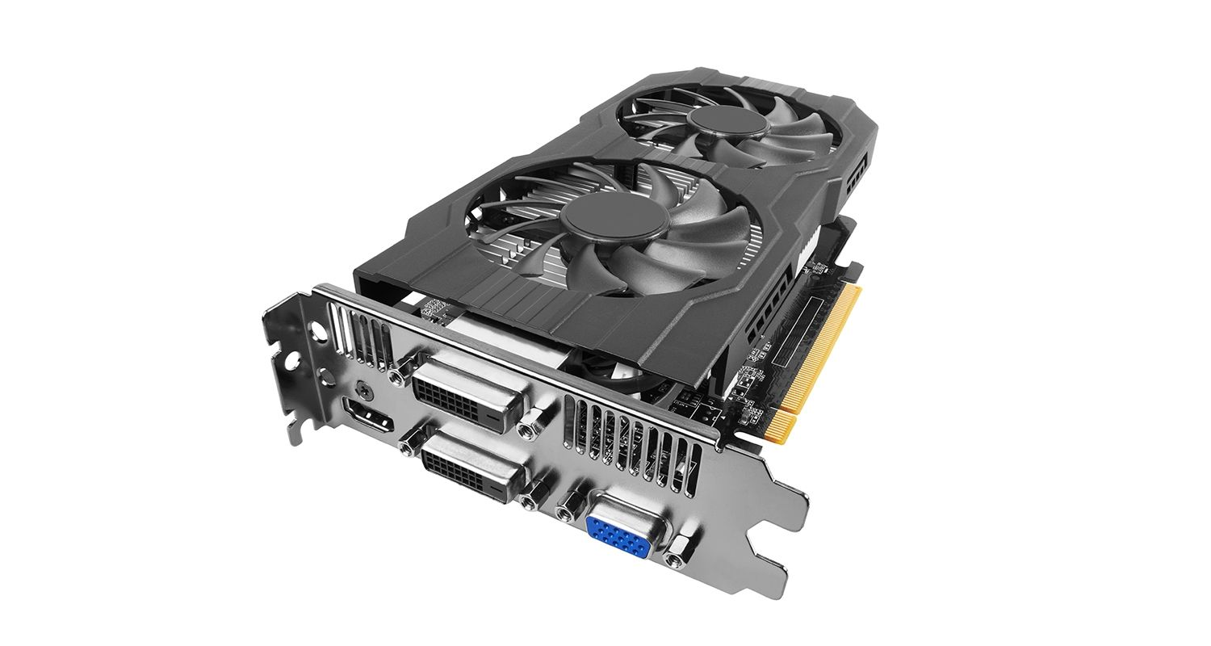

## Power Supply Unit (PSU)

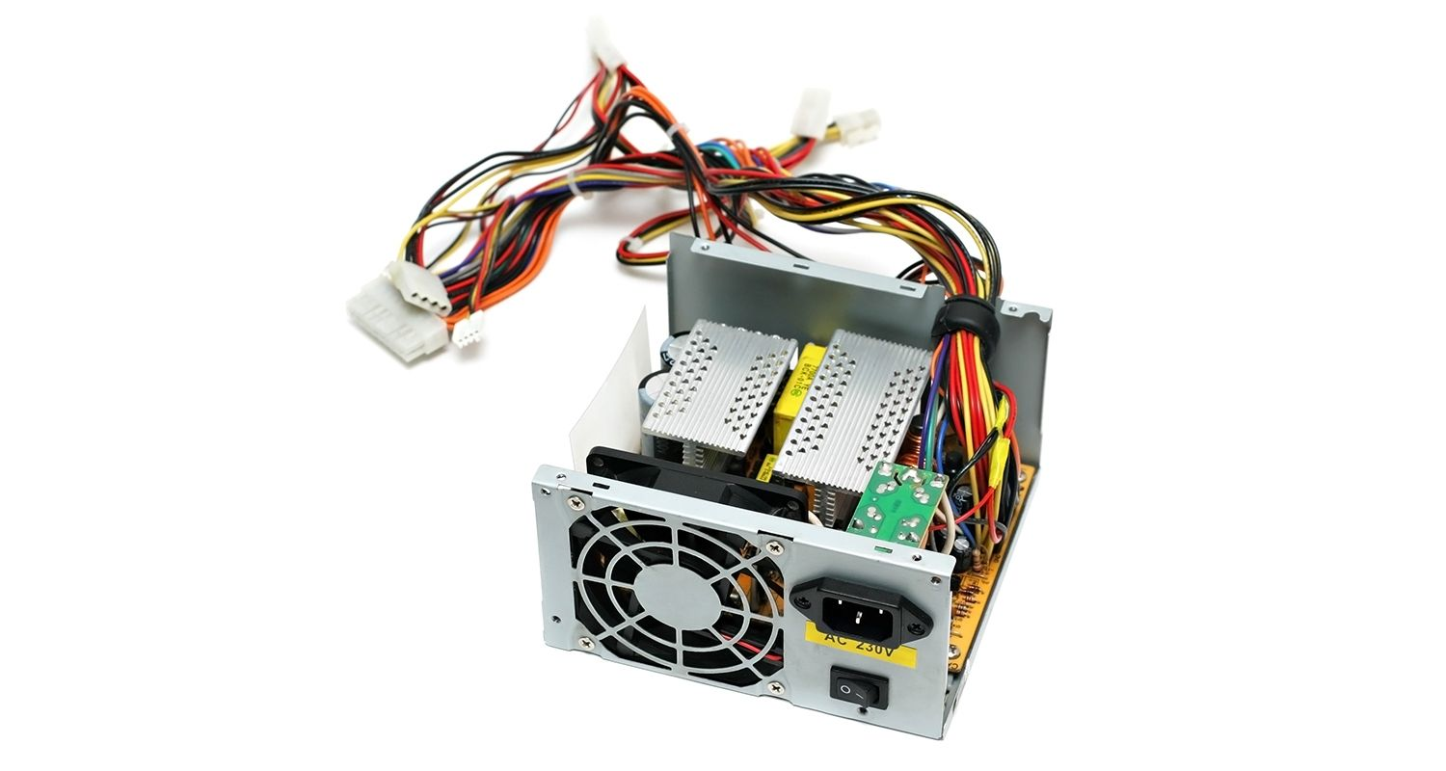A power supply unit, commonly abbreviated as PSU, does more than just supply your computer with power. It is the point where power enters your system from an external power source and is then allocated by the motherboard to individual component hardware. Not all power supplies are made equally however, and without the right wattage PSU your system will fail to work. Without the right amount of power, components won’t be able to run effectively and the computer might experience crashes or simply fail to boot at all.

### Sound Card

Most of the time, the sound chip built into the motherboard is used for audio output. But, if you are a sound enthusiast or prefer higher detailed audio while playing a game, you might be inclined to use a [sound card](https://computerinfobits.com/do-i-need-a-sound-card/).

Sound cards plug into a computer in multiple ways. It can be through USB, PCI slot, or PCI Express x 1 slot. A sound processing chip on the card does all of the audio processing and is usually not a very powerful processor.A sound card can offer a wide range of connectivity with various audio equipment.

A few examples could be optical audio, 1/4 inch jack, or RCA connectors.

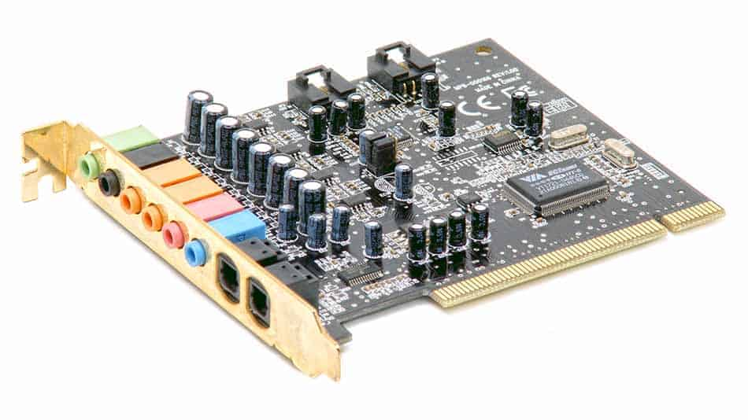

### SSD: Solid State Drive

An SSD is also a type of hard drive, but it doesn’t have any moving parts. It consists of a bank of flash memory that can hold a reasonable amount of data.

While SSD’s are increasing in size all the time, they aren’t cost-effective for storing large amounts of data. However, the SSD is a high-performance drive. It’s fast and cannot be as easily damaged by dropping it or taking a few knocks.

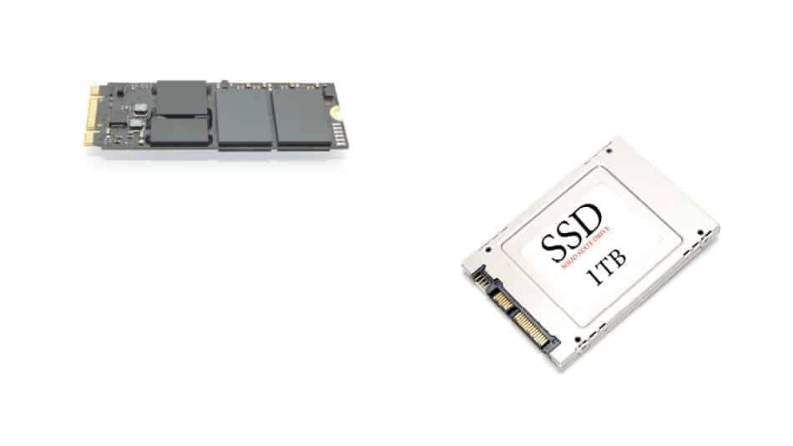

### Monitor or Visual Display Unit (VDU)

A [monitor](https://computerinfobits.com/what-is-a-monitor/) is what you use to visualize the graphics data sent from the computer’s graphics card.

There are various types of monitors on the market. The most commonly used is a LED-backlit LCD monitor.

There are also a variety of different sizes with different aspect ratios. The aspect ratio is simply the ratio between height and width.

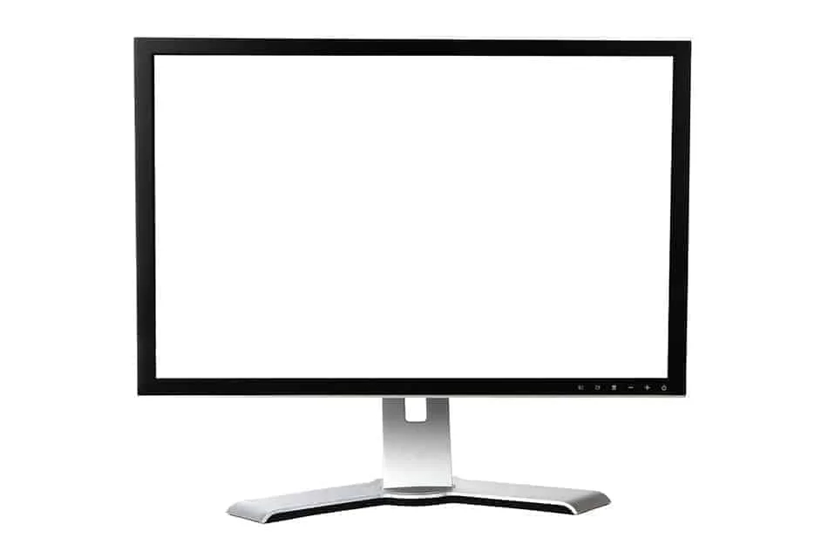

1. **Printers**

Different printers will have different features, but all of them should allow you to print text, pictures, or other files that you’ve saved on your computer.  
  
Printers connected to a computer either with a USB cable or over Wi-Fi.

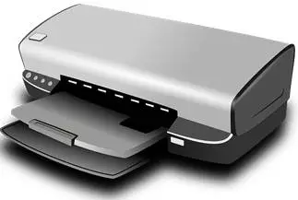

### ****Scanner****

Computer scanners are devices that convert images into digital or computerized information.The first scanners were large and expensive, but today they’re affordable and compact enough to fit on a desktop.  
  
A scanner allows you to copy anything from a picture to a receipt as well as images from magazines, newspapers, and books as long as it’s black and white.Scanners can be used for many purposes such as archiving family photos or creating an electronic form of your child’s artwork.

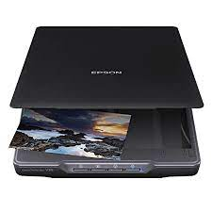

### ****Optical Disc Drive****

An optical disc drive is a device that reads data from a CD, DVD, or Blu-ray disc. Usually, it's a part of the computer's hardware.In the early days of computers, floppy disk drives were popular.They read data from disks made of magnetic material coated with iron oxide.  
  
However now, most people have moved on to digital files stored on hard disks and USB flash drives.Optical discs (CDs and DVDs) still exist and many people like to use them to store their favorite music or movies.

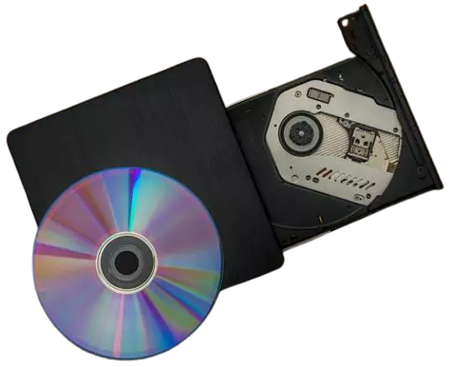

1. **Motherboard**

The motherboard is the backbone that ties the computer’s components together at one spot and allows them to talk to each other. Without it, none of the computer pieces, such as the CPU, GPU, or hard drive, could interact. Total motherboard functionality is necessary for a computer to work well.

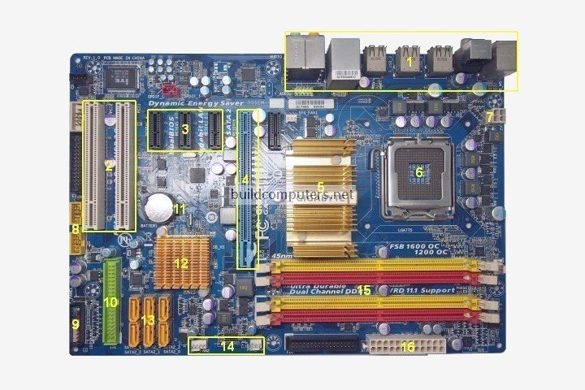

**Parts**

1. **Back Panel Connectors & Ports**

Connectors and ports for connecting the computer to external devices such as display ports, audio ports, USB ports, Ethernet ports, PS/2 ports etc.

1. **PCI Slots**

PCI: Peripheral Component Interconnect  
  
Slot for older expansion cards such as sound cards, network cards, connector cards.

1. **PCI Express x1 Slots**

Slot for modern expansion cards such as sound cards, network cards (Wi-Fi, Ethernet, Bluetooth), connector cards (USB, FireWire, eSATA) and certain low-end graphics cards.

1. **PCI Express x16 Slot**

Slot for discrete graphic cards and high bandwidth devices such as top-end solid state drives.

1. **Northbridge**

Also known as Memory Controller Hub (MCH).  
  
Chipset that allows the CPU to communicate with the RAM and graphics card.  
  
Beginning from Intel Sandy Bridge in 2011, this motherboard component is no longer present as it has been integrated within the CPU itself.

1. **CPU Socket**

Insert CPU here.

1. **ATX 12V Power Connector**

Connects to the 4-pin power cable of a power supply unit which supplies power to the CPU.

1. **Front Panel USB 2.0 Connectors**

Connects to USB 2.0 ports at the front or top of a computer case.

1. **Front Panel Connectors**

Connects to the power switch, reset switch, power LED, hard drive LED and

front audio ports of a computer case.

1. **IDE Connector**

Connects to older hard drive disks and optical drives for data transfer.

1. **CMOS Battery**

Supplies power to store BIOS settings and keep the real-time clock running.

1. **Southbridge**

Also known as the Input/Output Controller Hub (ICH).  
  
Chipset that allows the CPU to communicate with PCI slots, PCI-Express x 1 slots (expansion cards), SATA connectors (hard drives, optical drives), USB ports (USB devices), Ethernet ports and on-board audio.

1. **SATA Connectors**

Connects to modern hard disk drives, solid state drives and optical drives for data transfer.

1. **Fan Headers**

Supplies power to the CPU heat sink fan and computer case fans.

1. **RAM Slots**

Insert RAM here.

1. **ATX Power Connector**

Connects to the 24-pin ATX power cable of a power supply unit which supplies power to the motherboard.

1. **mSATA Connector**

Connects to a mSATA solid state drive. In most cases, this SSD is used as cache to speed up hard disk drives, but it's possible to re-purpose it as a regular hard drive.

1. **Front Panel USB 3.0 Connector**

Connects to USB 3.0 ports at the front or top of the computer case.

1. **Power & Reset Button**

Onboard button to turn on, turn off and reboot the computer.  
  
This motherboard component is more common among high end boards.

1. **RAM**

RAM (Random Access Memory) is the [hardware](https://www.techtarget.com/searchnetworking/definition/hardware) in a computing device where the operating system ([OS](https://whatis.techtarget.com/definition/operating-system-OS)), application programs and data in current use are kept so they can be quickly reached by the device's [processor](https://whatis.techtarget.com/definition/processor). RAM is the main memory in a computer. It is much faster to read from and write to than [other kinds of storage](https://www.techtarget.com/searchstorage/opinion/HDD-vs-SSD-storage-in-the-age-of-flash), such as a hard disk drive ([HDD](https://www.techtarget.com/searchstorage/definition/hard-disk-drive)), solid-state drive ([SSD](https://www.techtarget.com/searchstorage/definition/SSD-solid-state-drive)) or optical drive.

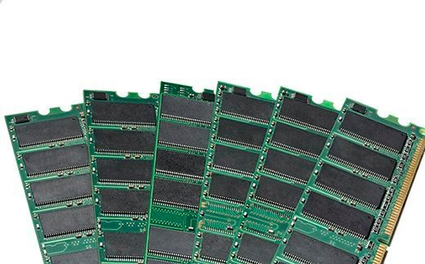

|  |  |
| --- | --- |
|  |  |
|  |  |

### Types of RAM

RAM comes in two primary forms:

* **Dynamic Random Access Memory (**[**DRAM**](https://www.techtarget.com/searchstorage/definition/DRAM)**)** makes up the typical computing device's RAM, and as was previously noted, it needs that power to be on to retain stored data.
* **Static Random Access Memory (**[**SRAM**](https://whatis.techtarget.com/definition/SRAM-static-random-access-memory)**)** also needs constant power to hold on to data, but it doesn't need to be continually refreshed the way DRAM does.

1. **ROM**

Read-Only Memory or ROM is an integrated-circuit memory chip that contains configuration data. ROM is commonly called firmware because its programming is fully embedded into the ROM chip. As such, ROM is a hardware and software in one.

Because data is fully incorporated at the ROM chip’s manufacture, data stored can neither be erased nor replaced. This means permanent and secure data storage.

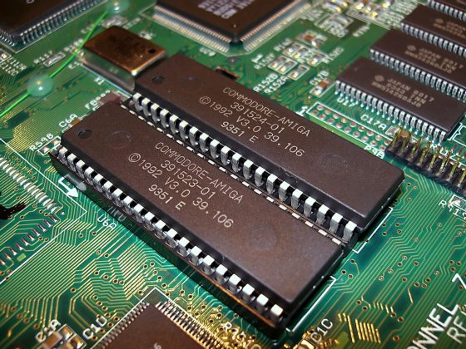

## RAM versus ROM

Both RAM and ROM provide the user random access to stored data. However, RAM provides only short-term memory since data stored in RAM is lost when power is turned off. ROM, on the other hand, provides long-term storage since data is permanently etched into the ROM chip.

One other difference between the two is that RAM’s data can frequently and speedily be altered and changed at will. ROM cannot be reconfigured at all.